Confidential - The information you provide on this form will be held confidentially by
The
KNOCKIE
TRUST
Qualifying Hardship and Distress
Grant Application Form
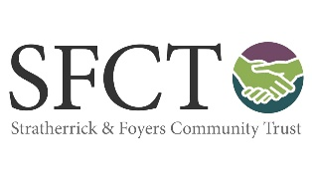
The Knockie Trust and Stratherrick and Foyers Community Trust.

Before you start, please make sure your application can tick all five of the following boxes.
Yes
I am resident in the Stratherrick and Foyers Community Council area.
I need up to £500.
My application does not include the repayment of debt.
My application does not include a request to pay an outstanding bill.
I understand the grant cannot be paid to me in cash, but can meet the cost of things I really need to buy.

If you have ticked all five boxes, then please continue.
How long have you lived in Stratherrick and Foyers?  . | Years | Months

Your Name

Your Address

Your Postcode

Email

Telephone Numbers

Please tell us the reason for your application – what you need and why you need help from this fund.
How much does this cost?

£

Declaration:
I certify that the information contained in this application is correct. I understand that decisions made by the Knockie Trust are final. I agree not to publicise any grant or help I receive.
Your signature

Date of signing this form.

